GALGOTIAS UNIVERSITY
School of Computing Science and Engineering
Department of Computer Science and Engineering
SOFTWARE ENGINEERING LAB
Subject Code: R1UC651B
Lab Manual and Experiment File
Project: Fin Tracker — Smart Expense Tracking Web Application
Technology Stack: HTML · CSS · JavaScript · Chart.js · LocalStorage · jsPDF

NAME | Abhishek | ENROL. NO.
PROGRAMME | B.Tech. CSE | SEMESTER | VI
SESSION | 2024–25 | SECTION

INDEX OF EXPERIMENTS
S.No. | Title of Experiment | Date | Sign
1. | Introduction to Software Engineering Tools
2. | Introduce Your Project — Fin Tracker
3. | Software Requirements Specification (SRS)
4. | UML Environment Familiarisation
5. | Data Flow Diagrams — Level 0, 1 and 2
6. | Entity-Relationship Diagram
7. | Flowchart Diagrams
8. | Use Case Diagrams and Scenarios
9. | Activity Diagrams
10. | Class Diagram
11. | Sequence Diagram
12. | Decision Tree and Decision Table
13. | State Diagrams

EXPERIMENT No. 1
Title: Introduction to Software Engineering Tools
Objective: To identify and demonstrate the key Software Engineering tools used across the Software Development Life Cycle, and to introduce the chosen project.

1.1 What is Software Engineering?
Software Engineering is the disciplined, systematic application of engineering principles to the design, development, testing, and maintenance of software. Unlike ad-hoc coding, it emphasises repeatability, documentation, and quality at every stage of the development lifecycle.
1.2 Core SE Tool Categories
- Version Control: Git and GitHub allow developers to track changes, collaborate on branches, and roll back defective releases. Every commit creates an auditable snapshot of the codebase.
- IDE / Code Editor: VS Code provides syntax highlighting, IntelliSense, debugging, and extension support — reducing context-switching and boosting developer productivity.
- Diagramming Tools: Lucidchart and draw.io are used to produce UML, DFD, and ER diagrams that communicate architecture to all stakeholders without requiring them to read code.
- Project Management: Jira and Trello implement Kanban and Scrum boards, keeping tasks, sprints, and blockers visible to the entire team.
- Testing Frameworks: JUnit (Java), Selenium (UI automation), and Postman (API testing) validate correctness at unit, integration, and system levels.
- Documentation Tools: Microsoft Word and Confluence store SRS documents, design specs, and user manuals in a structured, searchable form.

1.3 Diagram — SE Tools Overview
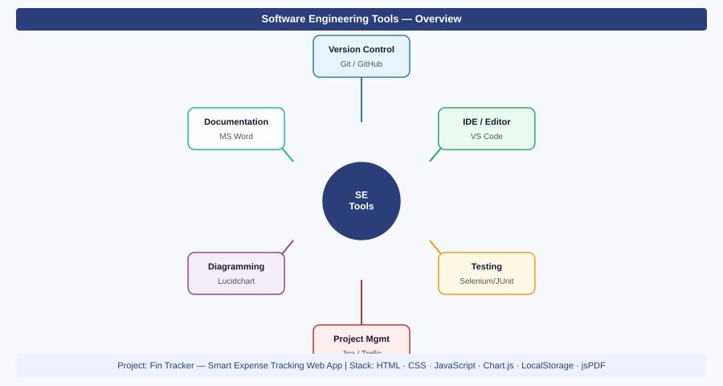
Figure 1.1 — Software Engineering Tools Mind Map with Fin Tracker project context

1.4 Chosen Project
Project Name: Fin Tracker — Smart Expense Tracking Web Application
Technology Stack: HTML5 · CSS3 · Vanilla JavaScript · Chart.js · LocalStorage · jsPDF · Font Awesome
Rationale: The project demonstrates a complete frontend SDLC — from requirements gathering through design, implementation, testing, and deployment — entirely within the browser without backend infrastructure.

Result: | Experiment completed successfully. All objectives were achieved as stated above.
Remarks: | Faculty Signature: ______________________

EXPERIMENT No. 2
Title: Introduce Your Project — Fin Tracker
Objective: To describe the problem domain, objectives, key features, and technical architecture of the Fin Tracker expense tracking application.

2.1 Problem Domain
Manual tracking of daily income and expenses leads to arithmetic errors, missed entries, and poor financial awareness. Spreadsheets require technical skill, while most commercial apps are either subscription-based or data-hungry. A lightweight, browser-native solution covers the gap.
2.2 Core Objectives
- Capture income and expense transactions in real time through a validated form interface.
- Visualise spending distribution by category using interactive Chart.js pie and bar charts.
- Enable users to download a formatted PDF financial summary using the jsPDF library.
- Persist all data across browser sessions using the Web LocalStorage API — no account needed.

2.3 System Architecture Diagram
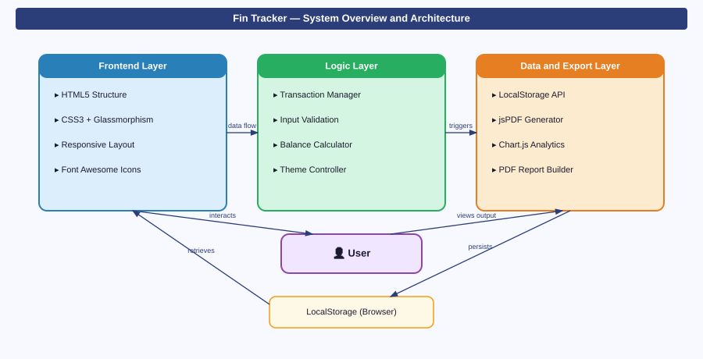
Figure 2.1 — Fin Tracker 3-Layer Architecture: Frontend, Logic, and Data/Export

2.4 Key Features at a Glance
Feature | Description
Add Transaction | Logs income/expense with title, amount, category, type, and date fields.
Delete and History | Removes entries and maintains a scrollable chronological transaction log.
Expense Analytics | Renders dynamic pie and bar charts from stored transaction data via Chart.js.
PDF Report Export | Generates a downloadable professional financial report using jsPDF.
Dark / Light Mode | One-click theme toggle with preference stored in LocalStorage.
Responsive and Offline | Fully functional on desktop, tablet, and mobile with no internet required.

Result: | Experiment completed successfully. All objectives were achieved as stated above.
Remarks: | Faculty Signature: ______________________

EXPERIMENT No. 3
Title: Software Requirements Specification (SRS) — Fin Tracker
Objective: To systematically document the functional and non-functional requirements of the Fin Tracker application in IEEE SRS format.

3.1 Introduction
Purpose: This SRS defines the intended behaviour, scope, and constraints of Fin Tracker — a browser-based personal expense management tool aimed at students and individuals seeking lightweight financial awareness.
Scope: The system captures, stores, and analyses income/expense transactions on the client side. No server, database, or user authentication is required for core functionality.

3.2 SRS Structure Diagram
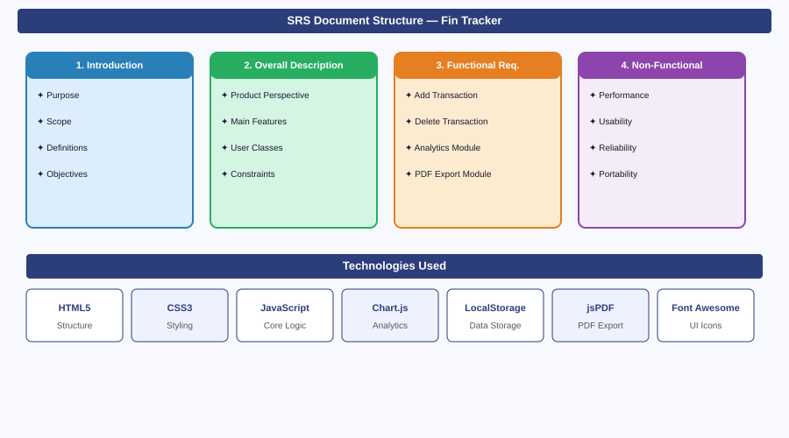
Figure 3.1 — SRS Document Structure with Technology Stack for Fin Tracker

3.3 Functional Requirements
- FR-01 Add Transaction: The system shall accept a title (text), amount (positive decimal), category (dropdown), transaction type (income/expense), and date from the user and persist the entry to LocalStorage.
- FR-02 Delete Transaction: The system shall remove a selected transaction by its unique ID and immediately recalculate all balance summaries.
- FR-03 Analytics Generation: The system shall read all stored transactions and render a Category Expense Pie Chart and a Monthly Trend Bar Chart using Chart.js.
- FR-04 PDF Export: The system shall compile all transaction records into a formatted jsPDF document and trigger a browser file download.
- FR-05 Theme Management: The system shall toggle between dark and light UI modes and save the preference to LocalStorage so it persists across sessions.
3.4 Non-Functional Requirements
- Performance: All UI updates must complete within 200 ms on a standard consumer device (no server round-trips involved).
- Usability: The primary task flow (add transaction) must be completable in fewer than five user interactions.
- Reliability: Transaction data stored in LocalStorage must survive page refresh and accidental tab closure.
- Portability: The application must render correctly on Chrome, Firefox, Edge, and Safari on both desktop and mobile viewports.

3.5 Technology Justification
Technology | Role in System | Why Chosen
HTML5 | DOM structure and form elements | Native browser support; semantic markup
CSS3 | Glassmorphism UI, responsive grid | No build step; backdrop-filter support
JavaScript (ES6) | Transaction logic, validation, DOM updates | Zero dependencies; instant execution
Chart.js | Pie and bar chart visualisations | Lightweight; canvas-based; responsive
LocalStorage | Client-side data persistence | No server required; 5 MB capacity
jsPDF | PDF report generation and download | Pure JS; no server-side rendering needed

Result: | Experiment completed successfully. All objectives were achieved as stated above.
Remarks: | Faculty Signature: ______________________

EXPERIMENT No. 4
Title: Getting Familiarised with the UML Environment
Objective: To understand the Unified Modelling Language diagram taxonomy and identify which diagram types apply to the Fin Tracker project.

4.1 Overview of UML
The Unified Modelling Language (UML) is an ISO-standardised visual notation for specifying, constructing, and documenting software systems. It is divided into two broad families: Structural diagrams (depicting static relationships) and Behavioural diagrams (depicting dynamic interactions over time).
4.2 UML Diagram Taxonomy for Fin Tracker
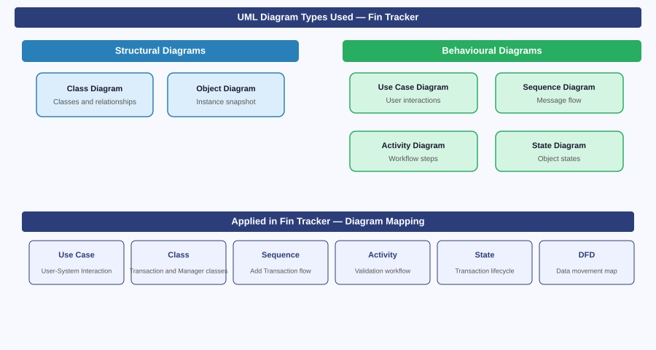
Figure 4.1 — UML Diagram Types Applicable to Fin Tracker

4.3 Diagram-to-Feature Mapping
UML Diagram | Fin Tracker Feature Covered | Exp. No.
Use Case | All user-system interactions | Experiment 8
Class | TransactionManager, AnalyticsEngine classes | Experiment 10
Sequence | Add Transaction message flow | Experiment 11
Activity | Validation and PDF export workflow | Experiment 9
State | Transaction lifecycle, Theme toggle states | Experiment 13
DFD (Structured) | Data movement between processes | Experiment 5

4.4 Tools Used for Modelling
- Lucidchart: Cloud-based diagramming platform with UML shape libraries, real-time collaboration, and SVG export.
- draw.io (diagrams.net): Open-source desktop and browser tool supporting UML, ER, and DFD diagrams with no account required.
- VS Code + PlantUML Extension: Text-based UML description language that auto-renders diagrams — ideal for version-controlled projects.

Result: | Experiment completed successfully. All objectives were achieved as stated above.
Remarks: | Faculty Signature: ______________________

EXPERIMENT No. 5
Title: Modelling Data Flow Diagrams — Level 0, Level 1, and Level 2
Objective: To construct and analyse DFDs at three levels of abstraction for the Fin Tracker application, tracing data movement from user input through processing to storage and output.

5.1 DFD Fundamentals
A Data Flow Diagram maps how data enters a system, which processes transform it, where it is stored, and how outputs are returned to external entities. DFDs are notation-neutral — they focus on what data moves, not how the code is written.
Symbol | Represents | Fin Tracker Example
Rectangle | External Entity | User
Rounded Rectangle | Process | 1.0 Add Transaction
Open-ended Rectangle | Data Store | LocalStorage
Directed Arrow | Data Flow | Store Data, Retrieve Data

5.2 Level 0 and Level 1 DFD
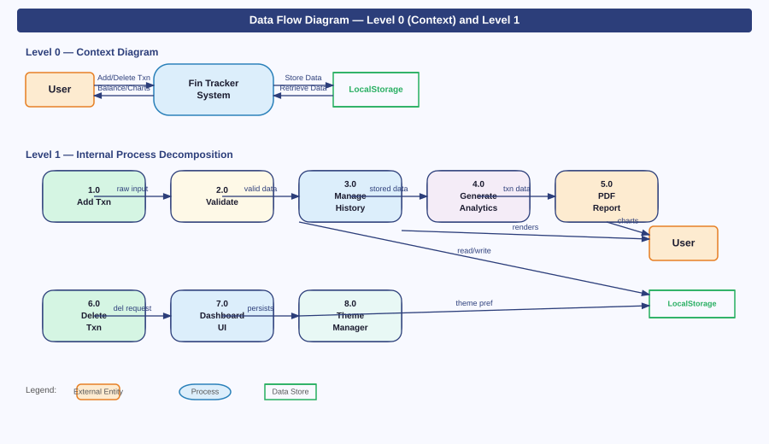
Figure 5.1 — DFD Level 0 (Context Diagram) and Level 1 (Process Decomposition) for Fin Tracker

5.3 Level 2 — Add Transaction (Process 1.0) Decomposed
- 1.1 Capture Input: The form collects title, amount, category, type (income/expense), and date from the User.
- 1.2 Validate Fields: JavaScript checks that no field is empty and that amount is a strictly positive number.
- 1.3 Assign ID and Timestamp: A UUID-style ID and the current epoch timestamp are appended to the transaction object.
- 1.4 Persist to LocalStorage: The complete transaction array (including the new entry) is serialised as JSON and written to browser storage.
- 1.5 Trigger UI Refresh: The transaction list, balance summary card, and Chart.js charts are re-rendered from the updated stored array.

Result: | Experiment completed successfully. All objectives were achieved as stated above.
Remarks: | Faculty Signature: ______________________

EXPERIMENT No. 6
Title: Modelling the Entity-Relationship Diagram for Fin Tracker
Objective: To design the logical data model of Fin Tracker using an Entity-Relationship diagram, identifying entities, their attributes, and inter-entity relationships.

6.1 ER Diagram Concepts
An ER diagram captures the data requirements of a system independent of its implementation. Each entity represents a real-world object with attributes; relationships capture how entities associate. Primary keys uniquely identify each record; cardinality (1:1, 1:N, M:N) specifies how many instances participate on each side.
6.2 ER Diagram — Fin Tracker
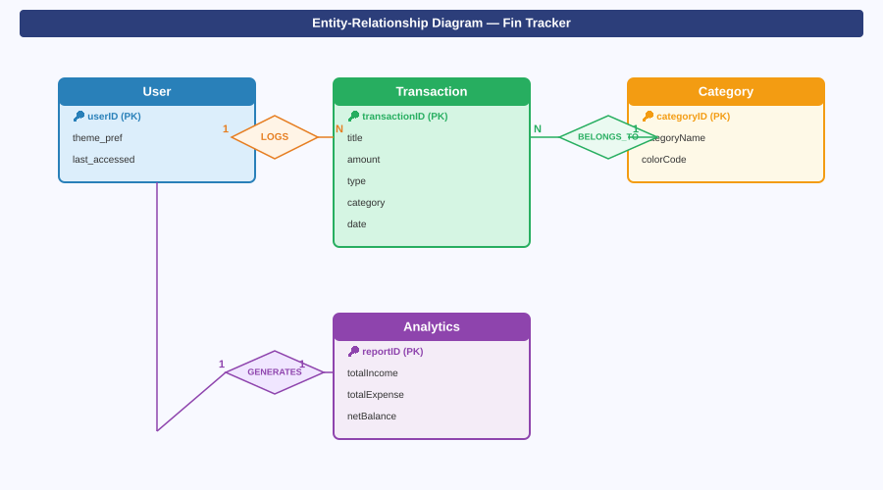
Figure 6.1 — Entity-Relationship Diagram for Fin Tracker showing four entities and three relationships

6.3 Entity Descriptions
- Transaction: Central entity. transactionID (PK) uniquely identifies each entry. Stores title, amount, type (income/expense), category, date, and timestamp.
- User: Holds theme_pref (dark/light) and last_accessed. userID (PK) scopes preferences — relevant when multi-user support is added in Phase 1 of the roadmap.
- Category: Stores categoryName (Food, Transport, Health, Shopping, Other) and colorCode for chart rendering. categoryID (PK).
- Analytics: Derived entity. Caches totalIncome, totalExpense, and netBalance for the current session. reportID (PK).
6.4 Relationship Cardinalities
Relationship | Cardinality | Meaning
User LOGS Transaction | 1 : N | One user can log many transactions; each transaction belongs to one user.
Transaction BELONGS_TO Category | N : 1 | Many transactions share one category; each transaction has exactly one category.
User GENERATES Analytics | 1 : 1 | One analytics snapshot exists per user session at any given time.

Result: | Experiment completed successfully. All objectives were achieved as stated above.
Remarks: | Faculty Signature: ______________________

EXPERIMENT No. 7
Title: Working with Flowchart Diagrams for Fin Tracker
Objective: To construct detailed algorithmic flowcharts for the Add Transaction and Delete Transaction processes, capturing all decision points and feedback loops.

7.1 Flowchart Notation
Flowcharts use standardised ANSI symbols: ovals mark start and end points, rectangles represent processes, parallelograms denote input/output, and diamonds mark decisions. Arrows show the direction of control flow. A well-formed flowchart has exactly one start node and at least one terminal node.
7.2 Add Transaction Flowchart
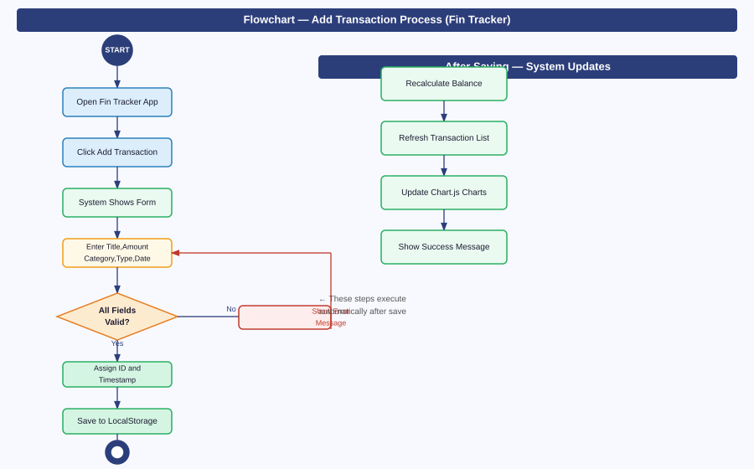
Figure 7.1 — Flowchart for the Add Transaction process with validation loop and post-save UI update cascade

7.3 Step-by-Step Trace
- Step 1 — User opens the Fin Tracker application and clicks the Add Transaction button.
- Step 2 — The system renders the input form with fields for title, amount, category, type, and date.
- Step 3 — User fills in all fields and submits the form.
- Step 4 — Decision node: Are all fields present and is the amount a valid positive number?
- Step 5 (No path) — A contextual error message highlights the offending field; control returns to the form.
- Step 6 (Yes path) — A unique UUID and epoch timestamp are assigned to the transaction object.
- Step 7 — The transaction object is appended to the stored array and written back to LocalStorage via JSON.stringify.
- Step 8 — The balance summary is recalculated, the history list is re-rendered, and Chart.js charts are refreshed.
- Step 9 — A transient success notification is displayed. Process terminates.

7.4 Delete Transaction — Control Flow
- User selects a transaction from the history panel and clicks the delete icon.
- The system filters the stored array by removing the entry whose ID matches the clicked item.
- The updated array is written back to LocalStorage; balance, income, and expense totals are recalculated.
- The history list and analytics charts are re-rendered. No confirmation dialog — deletion is immediate.

Result: | Experiment completed successfully. All objectives were achieved as stated above.
Remarks: | Faculty Signature: ______________________

EXPERIMENT No. 8
Title: Working with Use Case Diagrams and Capturing Scenarios
Objective: To model all user-system interactions of Fin Tracker as a Use Case Diagram and document detailed scenario narratives for three primary use cases.

8.1 Use Case Diagram Notation
A Use Case Diagram identifies actors (roles that interact with the system) and use cases (discrete system services). Associations connect actors to the use cases they invoke. Include relationships denote mandatory sub-cases; Extend relationships denote optional extensions that fire under specific conditions.
8.2 Fin Tracker Use Case Diagram
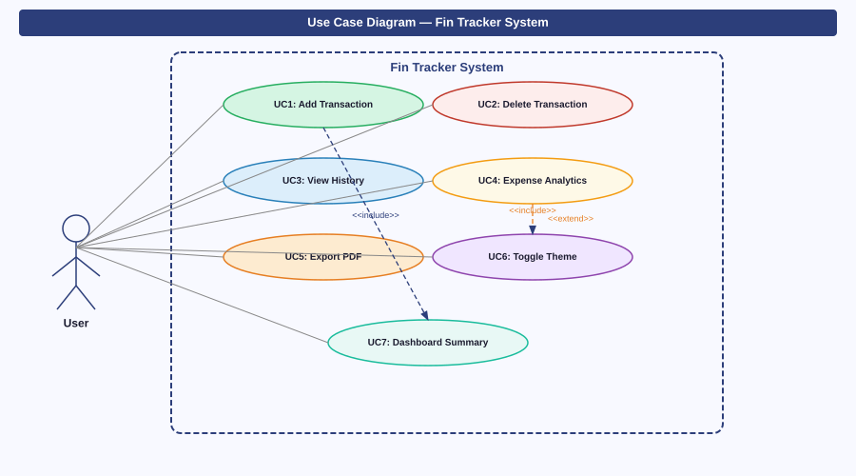
Figure 8.1 — Use Case Diagram for Fin Tracker with all seven use cases, include, and extend stereotypes

8.3 Use Case Scenario — UC1: Add Transaction
Use Case ID | UC-01
Name | Add Transaction
Actor | User
Precondition | Application is open in the browser.
Main Flow | User clicks Add; enters details; submits form; system validates, saves, and updates UI.
Alt Flow | If validation fails, system highlights the invalid field and prompts correction.
Postcondition | New transaction appears in history; balance and charts are updated.

8.4 Use Case Scenario — UC4: View Expense Analytics
Use Case ID | UC-04
Name | View Expense Analytics
Actor | User
Precondition | At least one transaction exists in LocalStorage.
Main Flow | User navigates to Analytics tab; system reads stored transactions, aggregates by category, and renders Chart.js pie and bar charts.
Postcondition | Charts display current spending distribution. User may optionally trigger PDF export (UC-05 extends this use case).

Result: | Experiment completed successfully. All objectives were achieved as stated above.
Remarks: | Faculty Signature: ______________________

EXPERIMENT No. 9
Title: Working with Activity Diagrams for Fin Tracker
Objective: To model the workflow and concurrent activity paths for the Add Transaction and PDF Export processes using UML Activity Diagram notation.

9.1 Activity Diagram vs Flowchart
While a flowchart traces algorithmic control flow within a single process, an Activity Diagram models behaviour across swim lanes (actors or components), supports parallel forks and joins, and maps naturally to object-oriented responsibilities. Activity Diagrams are especially useful where multiple objects collaborate.
9.2 Activity Diagram — Two Workflows
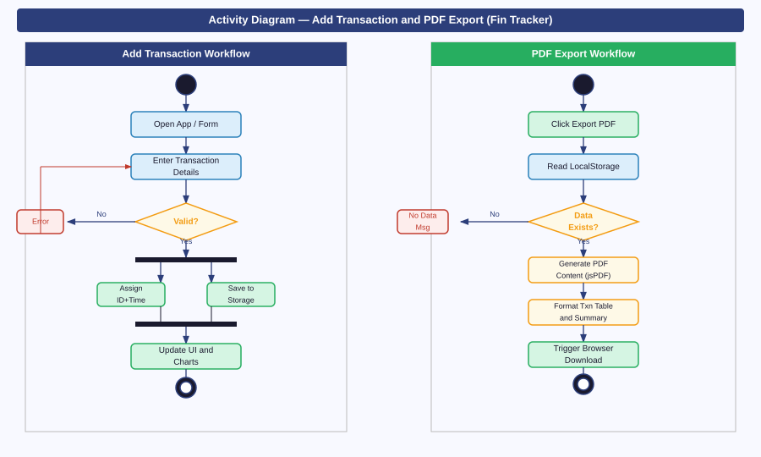
Figure 9.1 — Activity Diagrams for Add Transaction (left swim lane) and PDF Export (right swim lane)

9.3 Key Observations from the Add Transaction Workflow
- The Fork bar after validation simultaneously triggers ID assignment and LocalStorage persistence — these two actions have no data dependency and can execute in parallel.
- The Join bar ensures the UI update only begins after both parallel activities have completed, preventing a race between the display layer and the storage layer.
- The validation error path creates a tight feedback loop: the user is immediately returned to the form without losing already-entered data.
9.4 Key Observations from the PDF Export Workflow
- A guard condition at the start checks whether any transactions exist; an empty state triggers an informational message and returns to IDLE rather than producing a blank PDF.
- The jsPDF generation step is synchronous: it reads the full transaction array, formats a header and tabular body, computes a summary row, and only then triggers the browser download event.
- The final Download state is terminal — the browser saves the file to the downloads directory and control returns to the user.

Result: | Experiment completed successfully. All objectives were achieved as stated above.
Remarks: | Faculty Signature: ______________________

EXPERIMENT No. 10
Title: Working with Class Diagrams for Fin Tracker
Objective: To design and document the Class Diagram capturing all application classes, their attributes, methods, and the structural relationships between them.

10.1 Class Diagram Elements
A Class Diagram is the primary artefact of object-oriented design. Each class box is divided into three compartments: name (top), attributes (middle, prefixed with visibility: - private, + public), and operations (bottom). Relationships include Association (plain line), Composition (filled diamond — strong ownership), and Dependency (dashed arrow — usage without ownership).
10.2 Fin Tracker Class Diagram
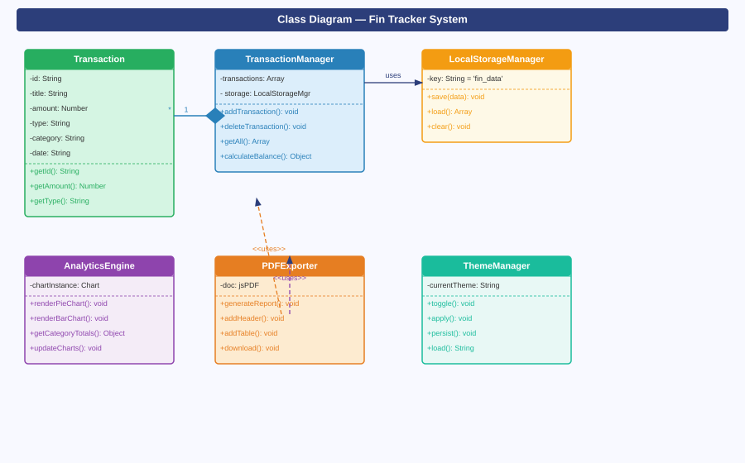
Figure 10.1 — Class Diagram showing six classes with attributes, methods, and inter-class relationships

10.3 Class Responsibilities
- Transaction: Plain data object. Stores all fields describing a single financial entry. Provides typed getters; no business logic.
- TransactionManager: Orchestrator. Owns the transaction array, delegates storage operations to LocalStorageManager, and exposes add, delete, getAll, and calculateBalance APIs to the UI layer.
- LocalStorageManager: Thin adapter over the browser's window.localStorage API. Handles JSON serialisation and deserialisation so all other classes work with native JavaScript objects.
- AnalyticsEngine: Reads the transaction array, aggregates totals by category, and drives Chart.js to render pie and bar charts. Maintains a reference to the active chart instance to destroy and recreate it on each update.
- PDFExporter: Consumes the transaction array from TransactionManager, builds a structured jsPDF document with a header, transaction table, and net balance summary, and triggers a browser file-save.
- ThemeManager: Reads the saved theme from LocalStorage on load, applies it to the document root element, and writes back whenever the user toggles.
10.4 Composition vs Dependency
TransactionManager COMPOSES Transaction objects (filled diamond, 1 to many) — transactions cannot outlive their manager. AnalyticsEngine and PDFExporter are DEPENDENT on TransactionManager (dashed arrows) — they use it only to read data and hold no permanent reference.

Result: | Experiment completed successfully. All objectives were achieved as stated above.
Remarks: | Faculty Signature: ______________________

EXPERIMENT No. 11
Title: Working with Sequence Diagrams for Fin Tracker
Objective: To model the time-ordered message exchange between objects during the Add Transaction interaction using a UML Sequence Diagram.

11.1 Sequence Diagram Concepts
A Sequence Diagram places objects on horizontal columns with vertical dashed lifelines. Activation bars show when an object is actively executing. Solid horizontal arrows represent synchronous calls; dashed arrows represent return values. Self-arrows represent internal processing (e.g., ID generation).
11.2 Sequence Diagram — Add Transaction
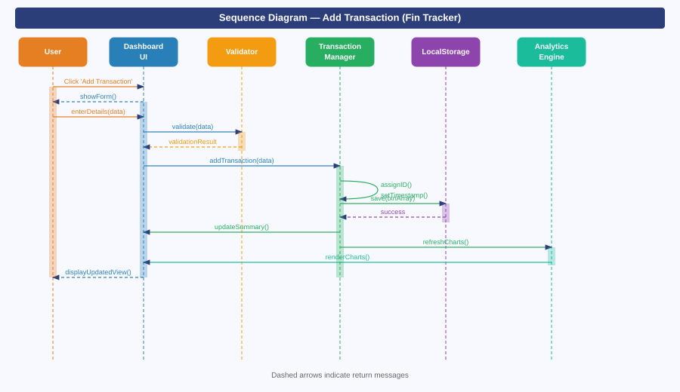
Figure 11.1 — Sequence Diagram showing six participating objects and thirteen message exchanges for the Add Transaction use case

11.3 Message Trace Explanation
# | Message | Description
1 | Click 'Add Transaction' | User initiates the action on the Dashboard UI.
2 | showForm() | Dashboard UI renders the input modal and returns control to user.
3-4 | validate(data) | Form sends raw input to Validator; Validator checks all constraints.
5 | validationResult | Validator returns pass/fail; on fail, form shows inline error and halts.
6 | addTransaction(data) | Validated data forwarded to TransactionManager for processing.
7 | assignID, setTimestamp | Self-messages: TransactionManager generates ID and timestamps internally.
8-9 | save / success | Array persisted to LocalStorage; success acknowledged.
10-13 | Update UI and Charts | TransactionManager notifies Dashboard UI and AnalyticsEngine to re-render.

Result: | Experiment completed successfully. All objectives were achieved as stated above.
Remarks: | Faculty Signature: ______________________

EXPERIMENT No. 12
Title: Working with Decision Trees and Tables for Fin Tracker
Objective: To construct a Decision Tree and corresponding Decision Table that formalise the input validation logic governing transaction submission in Fin Tracker.

12.1 Decision Modelling Overview
Decision Trees and Tables serve complementary purposes. A Decision Tree provides an intuitive visual trace through a chain of binary yes/no conditions to a terminal outcome. A Decision Table provides an exhaustive, compact, tabular enumeration of all condition combinations and their corresponding actions — making it easy to verify completeness and detect missing cases.
12.2 Decision Tree and Table — Validation Logic
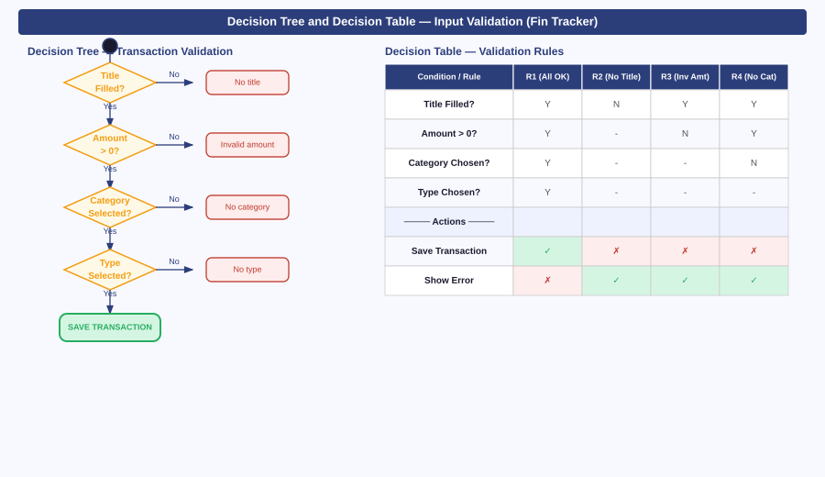
Figure 12.1 — Decision Tree (left) for transaction validation and Decision Table (right) showing four rules

12.3 Validation Rules Explained
- Rule R1 (All Valid): Title filled, amount greater than 0, category selected, type selected → system saves the transaction to LocalStorage.
- Rule R2 (No Title): Title field is empty → system displays 'Title is required' message without evaluating other fields.
- Rule R3 (Invalid Amount): Title present but amount is zero, negative, or non-numeric → system displays 'Enter a valid amount greater than 0'.
- Rule R4 (No Category): Title and amount valid but no category chosen → system displays 'Please select a category'.
12.4 Completeness Verification
The Decision Table accounts for four distinct failure modes. The dash symbol (-) in a condition cell indicates that the condition is irrelevant for that rule — i.e., the system has already failed on a higher-priority condition and short-circuits further checks. This implements a fail-fast validation strategy that surfaces the most critical error first.

Result: | Experiment completed successfully. All objectives were achieved as stated above.
Remarks: | Faculty Signature: ______________________

EXPERIMENT No. 13
Title: Working with State Diagrams for Fin Tracker
Objective: To model the internal state transitions of three key system components — Transaction Lifecycle, Theme Manager, and PDF Export Process — using UML State Machine Diagrams.

13.1 State Machine Notation
A State Diagram (State Machine Diagram) models an object as a finite set of states with transitions triggered by events. Guards in square brackets constrain when a transition fires. Entry and exit actions execute whenever a state is entered or exited. Initial pseudo-states (filled circles) and final states (bullseye) mark lifecycle boundaries.
13.2 Three State Machines
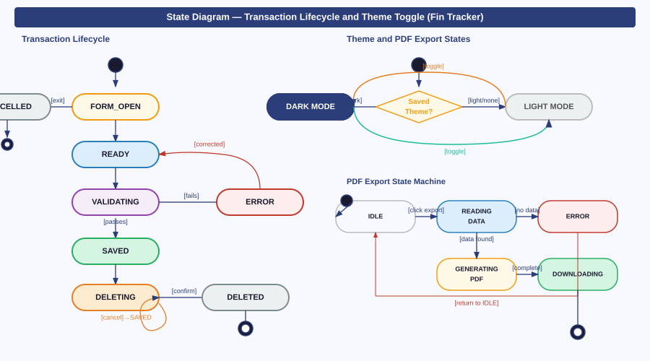
Figure 13.1 — State Diagrams for Transaction Lifecycle (left), Theme Toggle (top right), and PDF Export (bottom right)

13.3 Transaction Lifecycle States
- FORM_OPEN: User has clicked Add Transaction. Input fields are rendered and awaiting data entry.
- CANCELLED: User dismisses the form without submitting. Terminal state; no data is written.
- READY: All mandatory fields are populated and the form is eligible for submission.
- VALIDATING: System is checking field constraints. Transitions to VALIDATION_ERROR on failure or SAVED on success.
- VALIDATION_ERROR: One or more fields are invalid. User corrects the input, returning the object to READY.
- SAVED: Transaction has been written to LocalStorage and is visible in the history panel.
- DELETING: User has clicked the delete icon. Guard: confirmed → DELETED; cancelled → returns to SAVED.
13.4 Theme Toggle and PDF Export States
- Theme states: DARK_MODE and LIGHT_MODE toggle on user click. Each transition writes the new preference to LocalStorage, so the correct theme is restored on the next page load.
- PDF Export states: IDLE → READING_DATA → (empty guard: ERROR, back to IDLE) or (data found guard: GENERATING_PDF → DOWNLOADING → terminal). The ERROR state prevents jsPDF from generating a blank document when LocalStorage contains no transactions.

Result: | Experiment completed successfully. All objectives were achieved as stated above.
Remarks: | Faculty Signature: ______________________

